T H E
TRUMP ACCOUNT
BLUEPRINT

A Complete Guide for Every Family
What It Is • Why It Matters • How to Open One • Tax Strategies


Accounts Open July 4, 2026
Sign up free at TrumpAccounts.gov

WHAT IS A TRUMP ACCOUNT?

SIMPLE DEFINITION
A Trump Account is a federally established traditional IRA created specifically for children. It is NOT a savings account. It is NOT a 529 college plan. It is a long-term wealth-building vehicle designed to harness the full power of compounding over decades.

Key Facts
- The account is owned by the child — not the parent.
- A parent or guardian acts as custodian and manages the account until the child turns 18.
- Funds grow tax-deferred inside the account.
- Money is automatically invested in broad U.S. equity index funds (e.g., S&P 500-style ETFs).
- The U.S. government seeds qualifying accounts with a one-time $1,000 deposit.
- ANY child under age 18 is eligible to participate — you do not need to be born in 2025 to open the account.

ELIGIBILITY NOTE
Children born 2025–2028 are eligible for the $1,000 government seed deposit. However, ANY child under age 18 may have a Trump Account opened by a parent or guardian. The account is a gift of time — the earlier you open one, the more compounding works in your child's favor.

Source: IRS Form 4547 Instructions; IRS.gov; Investor.gov

WHY THIS CHANGES EVERYTHING

"Time in the market beats timing the market. A child born today has the ultimate advantage: time."

The Power of Compounding
Compounding is the process by which your earnings generate their own earnings — year after year. The longer money stays invested, the more dramatic the effect.

- Historical S&P 500 returns have averaged approximately 10% annually over the long term.
- $1,000 invested at birth and left untouched can grow to roughly $490,000 over 65 years at 10%.
- Even at more conservative 7% returns, that same $1,000 becomes over $80,000.
- Additional family contributions of even $100–$500/year can push that number into the millions.

THE BOTTOM LINE
Small dollars. Long timeline. Powerful outcome. The Trump Account is not about getting rich quick — it is about giving your child a head start that no paycheck alone can match.

Illustrations are hypothetical and not guaranteed. Past performance does not ensure future results.

HOW MUCH CAN BE CONTRIBUTED?

Source | Amount | Notes
U.S. Government | $1,000 (once) | Children born 2025–2028 only
Family & Friends | Up to $5,000/yr | Total across ALL contributors combined
Employer (optional) | Up to $2,500/yr | Counts toward the $5,000 annual cap

Source: IRS Notice 2025-68; TrumpAccounts.gov

HOW TO OPEN YOUR ACCOUNT

A complete walkthrough using a sample family — the Johnson family.

1 | Visit TrumpAccounts.gov

Go to form.trumpaccounts.gov on your phone or computer. You will see the official Trump Accounts enrollment portal. It is mobile-friendly and free to use.

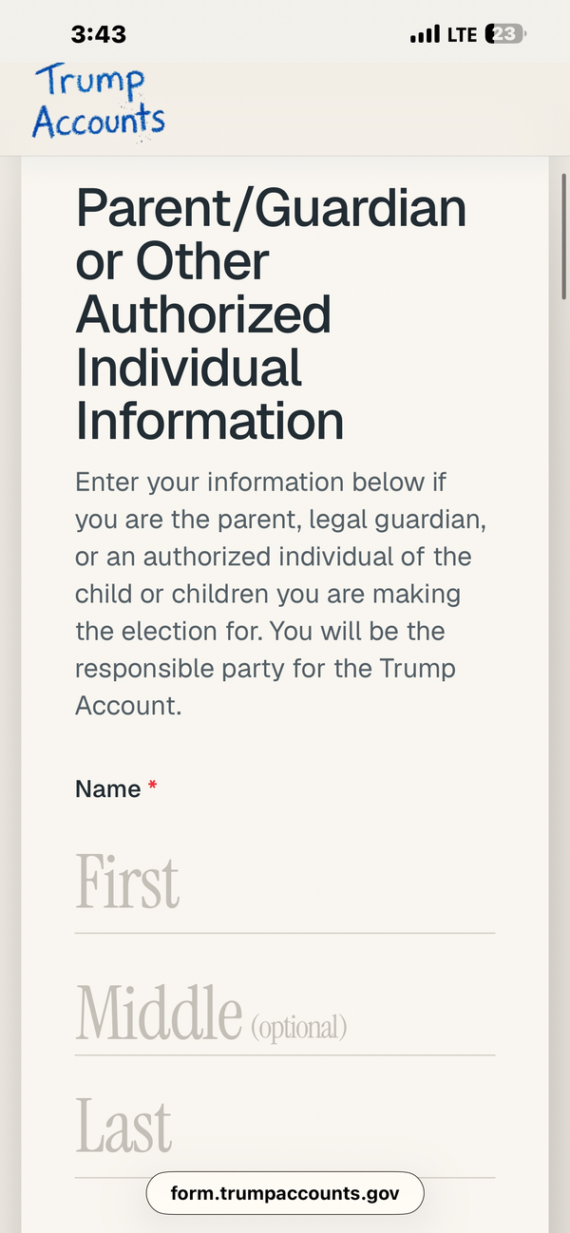
Screenshot: The official form.trumpaccounts.gov — Parent/Guardian Information section

2 | Enter Parent / Guardian Information

The first screen asks for your information as the responsible party (parent, legal guardian, or authorized individual). Use our sample family, the Johnsons, as a guide:

First Name | Marcus  Enter your legal first name as it appears on your SSN card

Middle Name | (optional)

Last Name | Johnson  Enter your legal last name

Social Security # | XXX-XX-1234  Your full SSN — kept private and secure

Date of Birth | March 15, 1988  Your date of birth

Mailing Address | 4821 Oak Street, Charlotte, NC 28201  Current home address

Email Address | marcus.johnson@email.com  For account confirmation and updates

3 | Enter Your Child's Information

Next, provide your child's details. Marcus is enrolling his 5-year-old daughter, Ava Johnson:

Child's First Name | Ava

Child's Last Name | Johnson

Child's SSN | XXX-XX-5678  Your child's Social Security Number

Date of Birth | June 3, 2019  Child's birth certificate date

Relationship | Parent  Parent, Legal Guardian, or Authorized Individual

IMPORTANT
Ava is 5 years old — well under age 18. Any child under age 18 is eligible to have a Trump Account. The $1,000 government seed applies specifically to children born 2025–2028, but ALL children under 18 can benefit from the tax-deferred growth and family contributions.

4 | Select the $1,000 Government Seed (if eligible)

If your child was born between January 1, 2025 and December 31, 2028, check the box on Part III of Form 4547 to request the $1,000 government pilot contribution.

- Ava was born in 2019, so she does not qualify for the seed deposit.
- However, Marcus can still open the account and begin contributing up to $5,000/year.
- If you have a newborn in 2025 or later, check this box — it is free money.

5 | Review, Sign & Submit

Review all information carefully. Then sign and submit one of three ways:

- ONLINE: Submit directly through form.trumpaccounts.gov (fastest).
- WITH YOUR TAX RETURN: Attach IRS Form 4547 to your federal tax return when you file.
- BY MAIL: Print and mail the completed form to the IRS address listed in the instructions.

WHAT HAPPENS NEXT
The Treasury will establish Ava's account and send Marcus a confirmation by mail or email within a few weeks. Accounts become fully active on July 4, 2026.

THE ROTH CONVERSION STRATEGY

"Pay a small tax at 18. Pay zero tax on all the growth after that."

What Happens at Age 18?
When Ava turns 18, she takes full control of her Trump Account. At that point, the account is treated as a traditional IRA. Here is the smart move most families will want to make:

THE STRATEGY
At age 18, before Ava has significant income, she converts some or all of her Trump Account balance into a Roth IRA. Because her income is low (she is likely a student or just entering the workforce), she pays income tax on the converted amount at the 10% or 12% rate — then never pays tax on that money again.

Why Convert at Age 18?
- At 18, most young adults are in the 10% or 12% federal tax bracket — the lowest rates available.
- A Roth conversion locks in that low rate forever. All future growth is 100% tax-free.
- Under current tax law, qualified Roth IRA withdrawals after age 59½ are completely tax-free.
- Converting early means decades of compounding happen inside a tax-free Roth wrapper.
- Ava could pay a small tax bill at 18, then withdraw hundreds of thousands tax-free at 60.

Roth Conversion Rules to Know
- Report the converted amount as ordinary income on Form 1040 in the conversion year.
- No 10% early withdrawal penalty applies to conversions (only to direct distributions).
- Converted funds must remain in the Roth for 5 years before earnings can be withdrawn tax-free (the '5-year rule').
- You can convert the full balance at once or spread it over several years to manage annual tax exposure.
- Consult a tax advisor to determine the ideal conversion schedule based on income at the time.

Source: GovFacts — Trump Accounts vs. 529 Plans vs. Roth IRAs: Tax Benefits Compared; IRS guidance on Roth conversions.

HOW IT COMPARES

Feature | Trump Account | 529 Plan | Roth IRA
Who owns it? | The Child | Parent | Individual
Govt seed money? | $1,000 ✓ | None | None
Annual limit | $5,000/yr | Varies | $7,000/yr
Tax treatment | Tax-deferred | Tax-free (education) | Tax-free growth
Age eligible | Birth to 17 | Any age | Earned income req.
Roth conversion? | Yes — at 18 | Limited rollover | Already Roth
Best use | Generational wealth | College savings | Retirement

KEY ADVANTAGE
The Trump Account is the only option that provides free government seed money AND is available to every child in America — not just those saving specifically for college or those with earned income.

THE BOTTOM LINE
✓ Free government money — up to $1,000 to start
✓ Any child under 18 is eligible
✓ Tax-deferred growth during childhood
✓ Roth conversion at 18 — then decades tax-free
✓ A real foundation for generational wealth
Small dollars. Big timeline. Powerful outcome.
Sign up free: TrumpAccounts.gov

Official Sources
- TrumpAccounts.gov / form.trumpaccounts.gov — Official enrollment portal (opens July 4, 2026)
- IRS Form 4547 — Download free at IRS.gov
- IRS Notice 2025-68 — Contribution and eligibility rules
- GovFacts — 'Trump Accounts vs. 529 Plans vs. Roth IRAs: Tax Benefits Compared'
- Investor.gov — Compounding calculators and investor education

DISCLAIMER: This guide is for informational purposes only and does not constitute tax, legal, or financial advice. Contribution limits, tax rules, and program details are subject to change. All growth projections are hypothetical and not guaranteed. Consult a qualified tax professional before making investment or tax decisions.

